**NITTE MEENAKSHI INSTITUTE OF TECHNOLOGY**

(AN AUTONOMOUS INSTITUTION, AFFILIATED TO VISVESVARAYA TECHNOLOGICAL UNIVERSITY, BELGAUM, APPROVED BY AICTE & GOVT.OF KARNATAKA

**PD LAB REPORT**

on

**FAKENEWS DETECTION**

*Submitted in partial fulfilment of the requirement for the award of Degree of*

*Bachelor of Engineering*

*in*

*Computer Science and Engineering*

*Submitted by:*

|  |  |
| --- | --- |
| V VENKATA SREE HARSHA | 1NT18CS181 |
|  |  |
|  |  |

Under the Guidance of

MRS MAHADEVI S

Assistant Professor, Dept. of CS&E, NMIT



Department of Computer Science and Engineering

**(Accredited by NBA Tier-1)**

2021-22

**NITTE MEENAKSHI INSTITUTE OF TECHNOLOGY**

(AN AUTONOMOUS INSTITUTION, AFFILIATED TO VISVESVARAYA TECHNOLOGICAL UNIVERSITY, BELGAUM

, APPROVED BY AICTE & GOVT.OF KARNATAKA)

Department of Computer Science and Engineering

**(Accredited by NBA Tier-1)**

**CERTIFICATE**

This is to certify that the PD Lab Report on **Fake News Detection** is an authentic work carried out by V Venkata Sree Harsha **(1NT18CS181)** ,bonafide students of **Nitte Meenakshi Institute of Technology**, Bangalore in partial fulfilment for the award of the degree of ***Bachelor of Engineering*** in COMPUTER SCIENCE AND ENGINEERING of Visvesvaraya Technological University, Belagavi during the academic year ***2021-2022.*** It is certified that all corrections and suggestions indicated during the internal assessment has been incorporated in the report.

|  |  |  |  |  |  |
| --- | --- | --- | --- | --- | --- |
| **Internal Guide** | | **Signature of the HOD** | | **Signature of Principal** | |
|  | |  | |  | |
| Mrs. Mahadevi S  Assistant Professor, Dept. CSE,  NMIT Bangalore | | Dr. SarojaDevi  Professor, Head, Dept. CSE, NMIT Bangalore | | Dr. H. C. Nagaraj  Principal,  NMIT, Bangalore | |
| **Signature of Examiners** | | | |
|  | |  | |
|  | |  | |
|  | |  | |

**DECLARATION**

We are hereby declare that

(i) The project work is our original work

(ii) This Project work has not been submitted for the award of any degree or examination at any other university/College/Institute.

(iii) This Project Work does not contain other persons’ data, pictures, graphs or other information, unless specifically acknowledged as being sourced from other persons.

(iv) This Project Work does not contain other persons’ writing, unless specifically acknowledged as being sourced from other researchers. Where other written sources have been quoted, then:

a) their words have been re-written but the general information attributed to them has been referenced;

b) where their exact words have been used, their writing has been placed inside quotation marks, and referenced.

(v) This Project Work does not contain text, graphics or tables copied and pasted from the Internet, unless specifically acknowledged, and the source being detailed in the thesis and in the References sections.

|  |  |  |
| --- | --- | --- |
| **NAME** | **USN** | **Signature** |
| V VENKATA SREE HARSHA | 1NT18CS181 |  |

Date: 30/01/2022

**ACKNOWLEDGEMENT**

The satisfaction and euphoria that accompany the successful completion of any task would be incomplete without the mention of the people who made it possible, whose constant guidance and encouragement crowned our effort with success. I express my sincere gratitude to our Principal **Dr. H. C. Nagaraj**, Nitte Meenakshi Institute of Technology for providing facilities.

We wish to thank our HoD**, Dr. Sarojadevi** for the excellent environment created to further educational growth in our college. We also thank him for the invaluable guidance provided which has helped in the creation of a better project.

I hereby like to thank our ***Mrs. Mahadevi S, Assistant Professor***, Department of Computer Science & Engineering on **her** periodic inspection, time to time evaluation of the project and help to bring the project to the present form.

Thanks to our Departmental Project coordinators. We also thank all our friends, teaching and non-teaching staff at NMIT, Bangalore, for all the direct and indirect help provided in the completion of the project.

|  |  |  |
| --- | --- | --- |
| **NAME** | **USN** | **Signature** |
| V VENKATA SREE HARSHA | 1NT18CS181 |  |

Date: 30/01/2022

**TABLE OF CONTENTS**

* Abstract
* Introduction
* Motivation
* Literature Survey and Objectives
* Proposed Architecture
* Results and Discussions
* Future Work
* Conclusion
* References

**Abstract:**

Web-based media for news utilization is a two-sided deal. From one viewpoint, its minimal expense, simple access, and quick dissemination of data lead individuals to search out and consume news from web-based media. Then again, it increases the wide spread of "fake news", i.e., low quality news with deliberately large data. The huge spread of fake news will affect people and society. Subsequently, counterfeit news identification on web-based media has as of late turned into an arising research that is drawing in gigantic consideration. Counterfeit news recognition via online media presents special qualities and challenges that make existing recognition calculations from traditional news media incapable or not pertinent. To start with, counterfeit news is deliberately composed to misdirect per users to accept large data, which makes it trouble and nontrivial to identify of the information content such as engagement of user on web media.

**Introduction:**

As an increasing measure in our lives we spent more time on surfing through social media, and many people will search out and get news from web-based media rather than customary news associations. The reasons for this change in utilization techniques are rooted in the nature of these web-based media stages: (I) it is generally expected more opportune and more affordable to consume news via web-based media contrasted and customary news media, like papers or then again TV; and (ii) it is more straightforward to additional offer, remark on, and examine the news with companions or different per users on online media. To assist with relieving the negative effects brought about by counterfeit news-both to help general society and the news system It's important that we foster techniques to naturally identify counterfeit news via online media.

**Motivation:**

The motivation behind this project is, in day to day basis there is a huge fake news spreading across the world. Some incident which was took place in some area will be passing that information to people in many ways. But that news which was passing to people is modified according to the people choice because of personal (or) political (or) some other reasons. So we came with a model such a way that it will identify the real news (or) fake news using some ML algorithms and other classifiers so that the given information which was given in the dataset which contains news is real (or) fake.

**Literature Survey:**

There are a few calculations for recognizing the fake news. For that we examine through various classifiers in various examination papers. The exactness acquired by utilizing Random Forest is 83 %, the precision got by utilizing PAC is 92.8%, , the exactness got by utilizing KNN is 79%, the precision got by utilizing Naive Bayes is 90%, and the exactness got by utilizing SGD is 77.2%. So in our process we used Passive Aggressive Classifier because it produced more accuracy.

Random Forest: It is a mix of decision trees. Here each tree will fabricate an arbitrary subset of a training dataset. In every decision tree model, an irregular subset of variables is utilized to divide the informational collection at every node.

PAC: Algorithms for online learning that are passive aggressive are known as passive aggressive algorithms. Such a thing exists. For a successful classification result, the algorithm remains passive and turns In the event of a miscalculation, be aggressive in updating and adjusting. Unlike the majority of people, It does not converge like other algorithms. Repair the loss with very little modification in the weight vector's norm.

KNN: The k-closest neighbors (KNN) calculation is a straightforward, directed AI calculation that can be utilized to take care of both characterization and regression issues. It's not difficult to execute and see, yet has a significant downside of turning out to be altogether eases back as the size of that information being used develops.

Naive Bayes: A Naive Bayes classifier expects that the presence of a specific element in a class is irrelevant to the presence of some other element.

Stochastic Gradient Descent: Stochastic Gradient Descent (SGD) is a straightforward yet extremely effective way to deal with fitting linear classifiers and regressors under convex-loss functions, for example, (direct) Support Vector Machines and Logistic Regression.

**Objectives:**

The main objective of this work is to **create a flask app and model that can use the data of past news report datasets and predict the chances of a news report being fake or not**. This predicting will be done using the passive aggressive classifier and TFIDF Vectorizer and also with the flask app with simple UI which connects with the model and app to gives whether the user input news in the flask app is real news (or) Fake News.

**Proposed Architecture:**

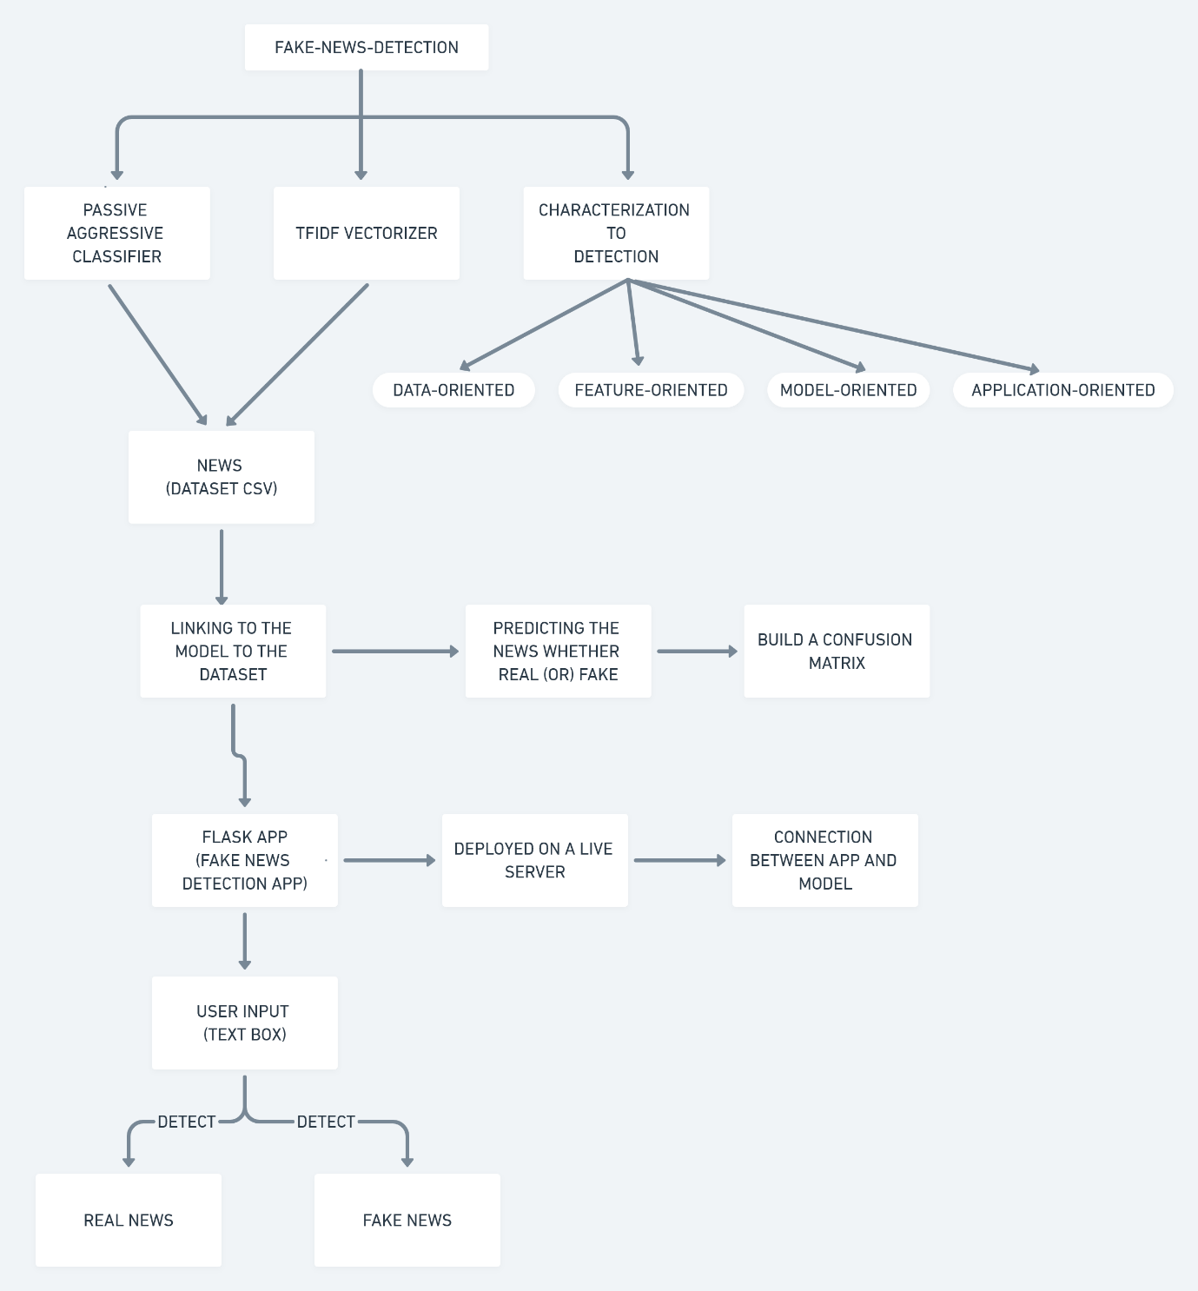

**RESULTS AND DISCUSSION:**

In this model we have used majorly some libraries, they are

1. Numpy
2. Pandas
3. Seaborn
4. Scikitlearn
5. Iter tools

Numpy: NumPy is a library in python and utilized for working with groups. It similarly has capacities with respect to working in area of straight polynomial math, Fourier change, and frameworks. NumPy was built in 2005 by Travis-oliphant. It is an open-source endeavor, and you can use it in N-number of times. NumPy addresses Numerical Python.

Pandas: Pandas is a quick, adaptable, and strong python apparatus utilized for information examination and control.

Seaborn: Seaborn is a Python data portrayal library taking into account matplotlib. It gives a critical level mark of connection to drawing appealing and illuminating quantifiable plans.

Sci-pack learn: Sci-unit learn is reasonable the most supportive library for AI in Python. The sklearn library contains a huge load of useful gadgets for AI and genuine showing including relapse, grouping, and dimensionality decline.

Itertools: Itertools is a python-module, it is made to re-hash over DS that can be used over using a for-circle. Such data structures are generally called iterables. This module joins works that utilization computational resources capably.

Regarding the dataset, the dataset is loaded in the google drive and mounted in the google drive.

For all these things we need some minimum system requirements:

1. Windows 10 (or) More
2. Visual Studio Code With Python Installed
3. RAM: 4GB & ROM: 50Gb
4. Google Colab
5. Processor: Intel i5 (or) More
6. Live Server

So these are some minimum requirements for the model and app that can be worked in the system.

So, in this project we have tested with so many news from the dataset whether that particular news is real news (or) fake news.

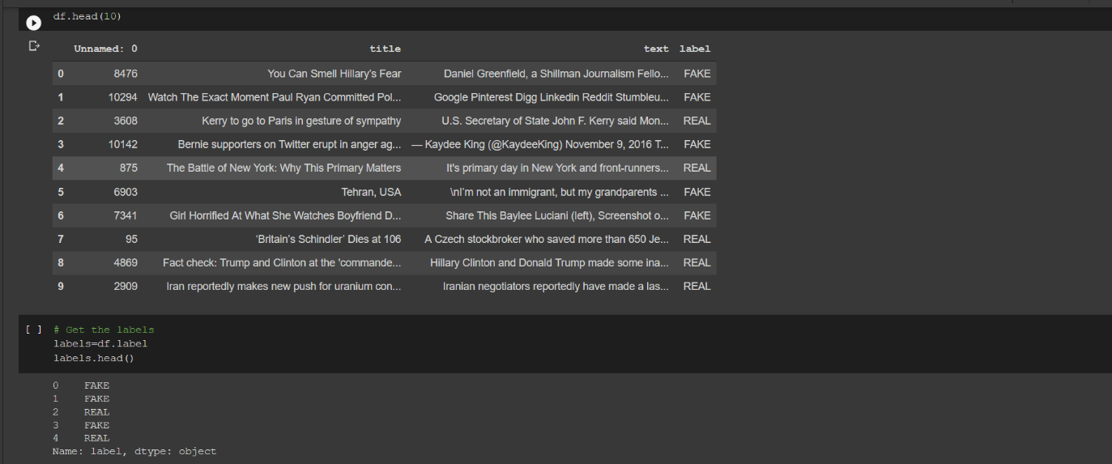

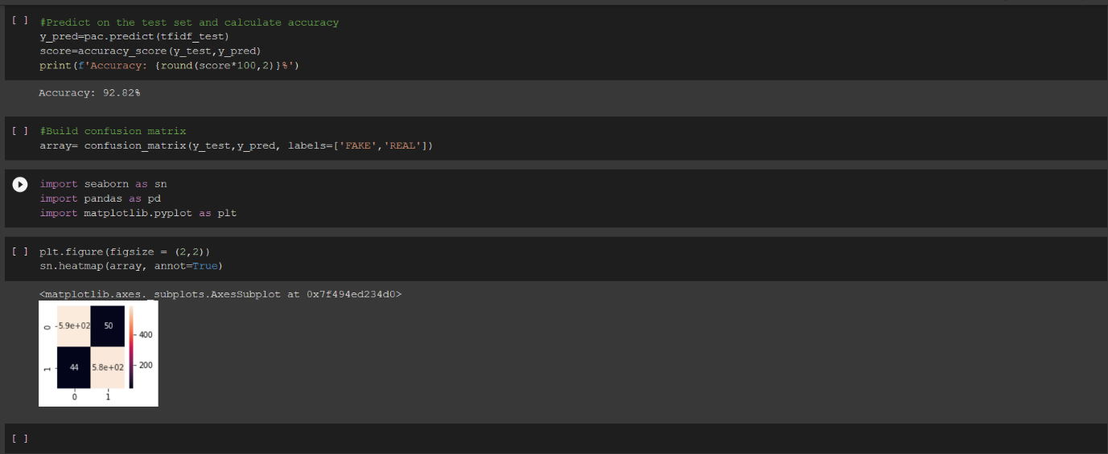

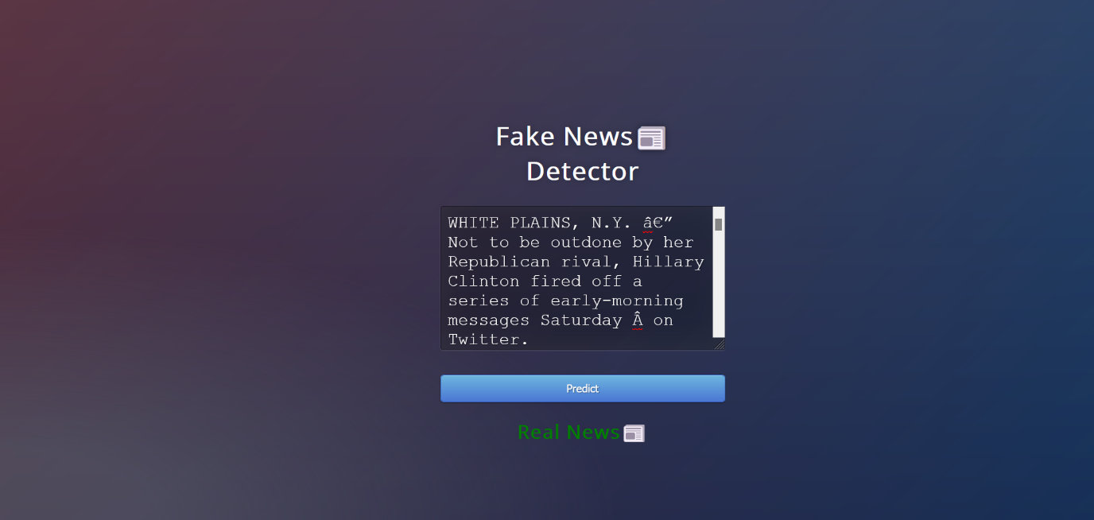

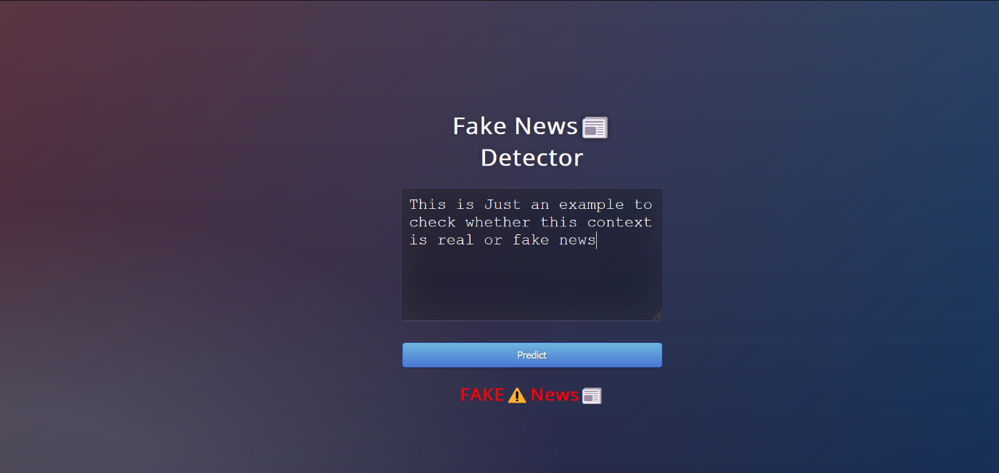

**FUTURE WORK:**

This app and model what we have built is hosted in the local server, but in future we need to host on the internet so that everyone can access. And also, we will try to give this app to the researchers to check whether the news what they are researching is real (or) fake news by using the datasets what the researchers are working on. And also, this model what we have made is having 92% accuracy, with the help of passive aggressive classifier. If any new algorithm has been discovered for classification then we will try with that new algorithm because there might be a chance that particular algorithm will be faster and more efficient than passive aggressive classifier.

**CONCLUSION:**

With the increasing popularity of social media, more and more people consume news from social media instead of traditional news media. However, social media has also been used to spread fake news, which has strong negative impact son individual users and broader society. So, with the help of this model we will be able to detect whether the particular news is real news (or) fake news.

**REFERENCES:**

<https://www.sciencedirect.com/science/article/pii/S1877050918318210>

<https://www.hindawi.com/journals/complexity/2020/8885861/>

<https://arxiv.org/pdf/1708.01967.pdf>

<https://www.geeksforgeeks.org/passive-aggressive-classifiers/>

<https://scikitlearn.org/stable/modules/generated/sklearn.feature_extraction.text.TfidfVectorizer.html>

<https://docs.python.org/3/library/itertools.html>

Meital Balmas. When fake news becomes real: Combined exposure to multiple news sources and political attitudes of inefficacy, alienation, and cynicism. Communication Research, 41(3):430–454, 2014.

Manish Gupta, Peixiang Zhao, and Jiawei Han. Evaluating event credibility on twitter. In PSDM’12.